FDMC Dinner Dance – Ticket Order Form
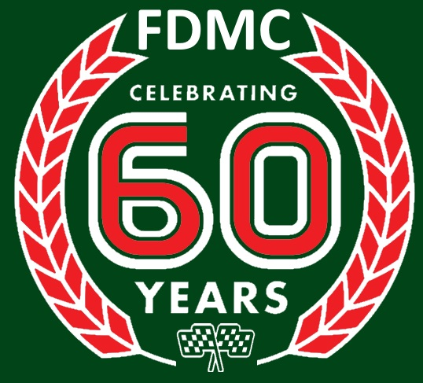
60th Anniversary Dinner Dance & Awards Presentation
Saturday
3rd March 2018
Lismoyne Hotel, Fleet, GU51 4NE

Your name: ___________________________________
Address: __________________________________________________
__________________________________________________
Postcode: _________________
Phone: ___________________________________________________
Email: ___________________________________________________
Number of Tickets: _____ @ £40 each (tables will sit 8-10 persons).
Names of others in your party: ___________________________________
_____________________________________________________________
Other people you would like to sit with: ____________________________
______________________________________________________________
Cheques payable to “Farnborough District Motor Club” or pay online at www.fdmc.org.uk/dinnerdance18. Menu options will follow by return.
Send completed forms by post or email a photo/scan to:
Post: Simon Taylor, 27 Lime Drive, FLEET, GU51 2XJ
Email: simontaylor@fdmc.org.uk

