FDMC Bramley Targa 2018: Final Instructions, Part 1
Bramley Military Training Area - 18th March 2018

Read this carefully, in conjunction with the Supplementary Regulations

Thank you for your entry, these Part 1 Final Instructions are to help you prepare for the event. At the event, you’ll receive all the remaining paperwork, including competition numbers, and the Part 2 Final Instructions. There’s a current entry list attached and on FDMC’s website, on the Bramley Targa 2018 Entry Page.

- Vehicle paperwork:
Remember, as per the MSA regulations for Targas, for competing cars ensure that the car is currently taxed, and that you bring all the following:
- Evidence that the vehicle is taxed (A print-off from here will be needed)
- A current insurance certificate or cover note
- A current MOT certificate, if the car is more than 3 years old
- Your current club membership card, or join FDMC on the day (£20 for a year)
- You need separate Club cards for the Driver and a second for your Navigator.
- Your vehicle entry pass (to be printed or displayed on a mobile device, and presented at the site entrance
- Timetable, on arrival

Parking
Competing cars and trailers MUST park as directed in the paddock area, non-competing cars must park in the areas away from the competing cars. Please display Pass with your name on the dash.

Site opening, signing-on and scrutineering will start from 08:00. Please do not arrive before 08:00.
Recommended latest arrival is by 08:30.
No access to the venue will be allowed after 09:00.
Exclusion will apply if you have not signed on by 09:30.
- On arrival, unload, leaving any trailers in the trailer park, and other equipment in your designated paddock space.
- Proceed to noise check, and then get your car scrutineered.
- Then take the noise check and scrutineer’s ticket to the HQ, to get your Part 2 Final Instructions and all other relevant documentation.
You can then visit the catering van, before a drivers’ briefing at 09:30. The first car starts at 10:01, but may be required to book in at MTC1 at some time before that.

- Car preparation
Please ensure that your car complies fully with the requirements of SR7 and 8.
Special preparation isn’t required, beyond basic safety checks, ensuring no loose objects in the car or the boot, and that nothing’s loose or leaking under the bonnet. Have the oil level at maximum, to minimise any chance of oil surge (oil pressure loss) when cornering.

REMINDER: All tyres used must be fully road legal. No tyres from Lists 1B or 1C are permitted, and no tyres of a blatantly “Knobbly” or “M&S” design are permitted. This issue is at the organisers’ discretion. Please call the Clerk of the Course if in doubt, BEFORE the day of the event.
- Facilities
We will have a caterer on site so please give them your custom to retain this service for future events. 2 Site Toilets will be provided (1 reserved for the ladies). The site has no covered shelter. If the weather outlook is at all uncertain, bring some weatherproof clothing.

- Photos
M&H Photography will be photographing parts of the event. If you would like proofs emailed to you please drop your email address to Andrew at mandh_photography@live.co.uk
Photos from the event may appear on the FDMC website, and on the websites of photographers. If this could cause any embarrassment, please notify the Officials in writing and cover your number plates.

- Directions
The venue is the Bramley Military Training Area, Hampshire; enter via MR175/186 6505 5930,
which is near to Post Code RG26 5BP. The entrance is shown by the yellow cross, below.
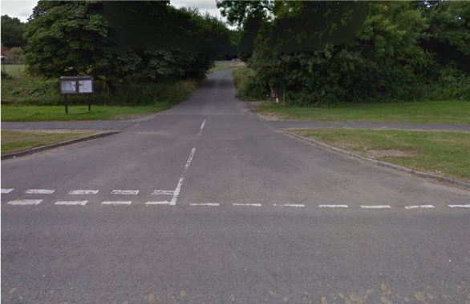
This shows the turning from The Street, Bramley, to the site entrance lane:

There should also be orange arrows from this junction.
On entering the site follow the directions, driving carefully and slowly.

Any problems/queries please feel free to contact us as follows:
- Clerk of the Course - Simon May - 07929 086885 (between 07:00 & 22:00 only, please), or01252 513985 (between 18:30 & 21:00)
- Secretary of the Meeting - Graham Skeggs - 01252 659044 or 07721 754168 - (between 18:30 & 20:30 only, please).
- Chief Marshal – Simon Taylor - For marshalling offers, please call 07966826706
- Child and Vulnerable Adult Protection Officer – Jessica Castle 07454 214583.

Looking forward to a great event!

The Organisers.

