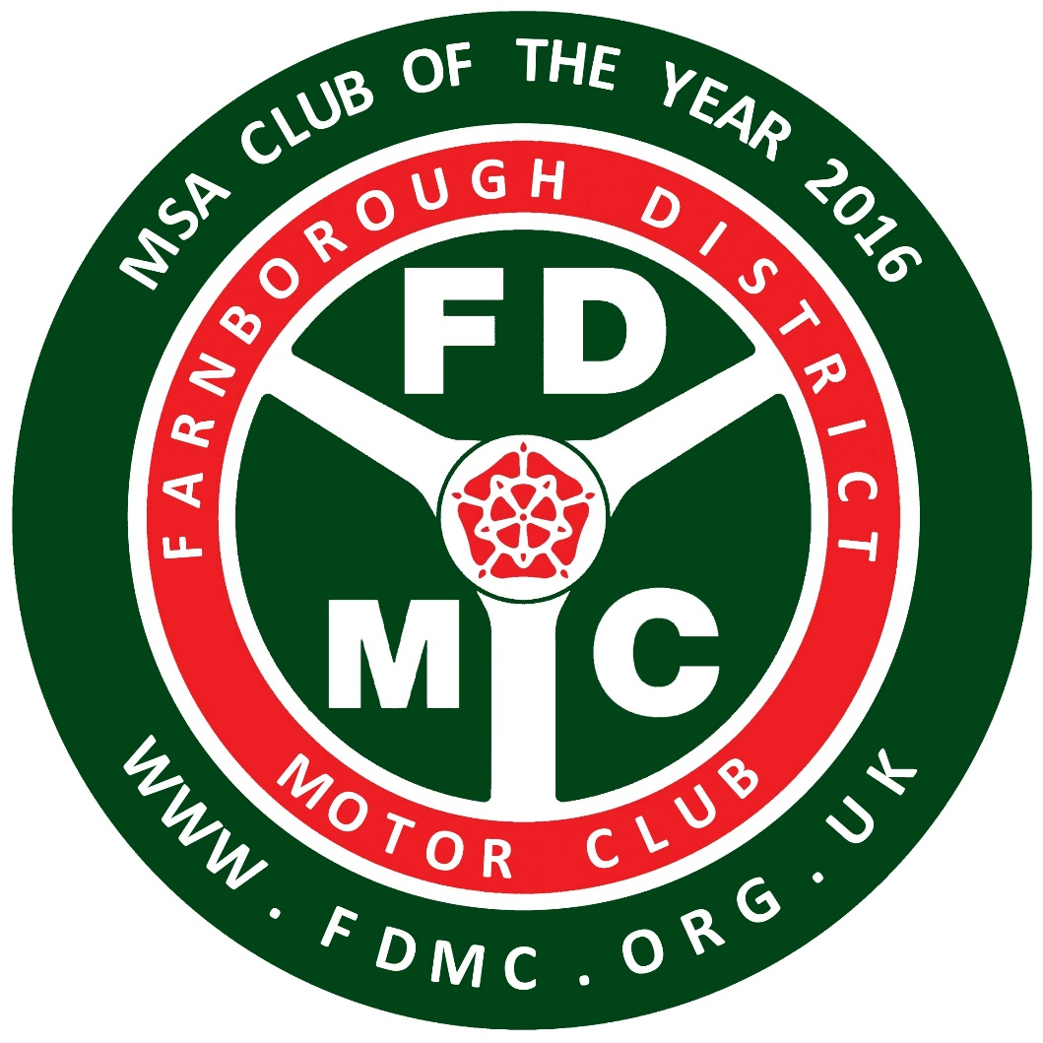
VEHICLE ENTRY PASS
FDMC Bramley Targa Rally
RG26 5BP (but not before 8am.)
18th March 2018
Entry pass – (Cross out not applicable)
Competitor
Competitor support
Marshal
Official

Print Name : __________________

